A000-Afr-Burkina Faso-Niger River Delta-Bura Head with Gorget-Terra cotta-3rd to 11th century CE

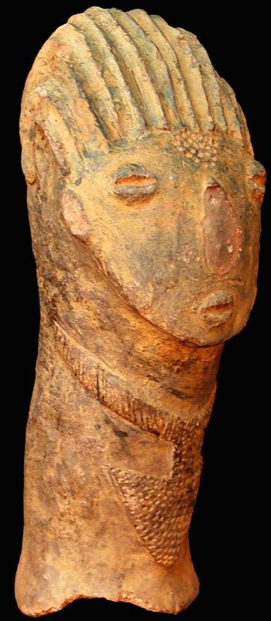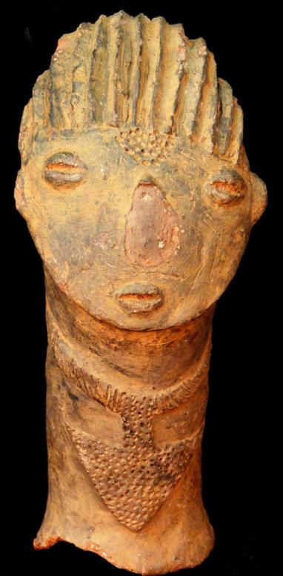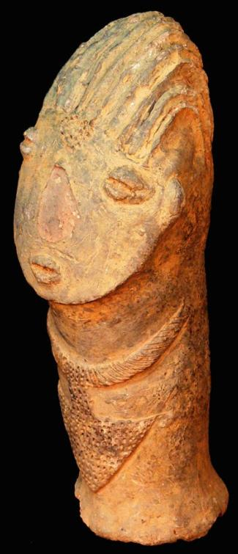

Fig. 1. Afr-Burkina Faso-Niger River Delta-Bura Head with Gorget-Terra cotta-3rd to 11th century CE

**Accession No.**

**Formal Label:** Afr-Burkina Faso-Niger River Delta-Bura Head with Gorget-Terra cotta-3rd to 11th century CE **Display Description:**

Niger, Bura Iron Age culture (3rd to 11th century CE)-Terracotta head, excellent condition showing fine detail of a gorget in the form of a massive projectile point, facial features and hair style. This terracotta figure possibly of an ancestor depicts a head with an elongated neck. This head is modeled in a style known as proto-Dogon found in the Niger Delta, based on its facial details. Numerous clay objects have come to light from the great Inland Delta Cultures of the Niger River and Benue River confluence. The figure was fired at a relatively low temperature to give it the brownish-red color.

Bura includes 3 types of sites that are not always easy to distinguish from each other:  
 1) Sites with necropolis proper characterized by a particular kind of coffin jars or anthropomorphic funerary urns made up of pottery surmounted by heads of statuettes, placed upside down on the ground and containing human skeletons in Asinda-sikka. These sites include 2 distinct archaeological levels. This is the type of site from which the present head has come.   
 2) Sites of religious altars and ritual ceremonies characterized by piles of large blocks of stone form a sort of flattened tumulus or esplanades such as Asinda-Sikka, Karey-Tondi, Jajé-Tondi or Mebera-Tondi There are fragments of feet of tripod vases and fragments of pottery in the form of small painted cylinders.  
 3) Housing sites difficult to identify. But the discovery of fragments of tripod vases and sometimes of small piles and alignments of large blocks of stone testify to a human presence. Also on the site are quarrying wastes of quartzites or flint representing the site of arched framework and thin ceramic of Kosendo-gorizo ​​located to the west of necropolis, behind a hill.  
  
 The general articulation of the system of occupation of space sites in Bura seems to revolve around two poles, the necropolis and the religious altar. The necropolis is almost always located in protected places. In the necropolis, anthropomorphic terracotta coffins or anthropomorphic funerary urns were laid upside down on the original floor and were then covered by a remobilization of the wind after the 13th century.  
 Funerary urns are generally surmounted by heads of anthropoid statuettes presenting a generally anthropomorphic form. Three types of funerary urns can be distinguished:  
    1. Longiform or tabular vases 70 to 80 cm high and 10 to 30 cm in diameter, surmounted either by complete statuettes of a person or mounted rider. These vases serve as supports for statuettes and sometimes form their bodies.  
    2. Hemispheric vases 20 to 40 cm high and 10 to 30 cm in diameter generally topped by statuette heads. This is probably the origin of the current terra cotta head.   
    3. Semi-ovoid jars, approximately 50 to 70 cm in diameter and 40 to 60 cm in diameter, supporting either complete statuettes or statuette heads.

**LC Classification:**

**Date or Time Horizon:** 3rd to 11th century CE

**Geographical Area:**

**Map:**

**GPS coordinates:**

**Cultural Affiliation:**

**Media:**

**Dimensions:**

**Weight:**

**Condition:**

**Provenance:**

**Discussion:**

**References:**

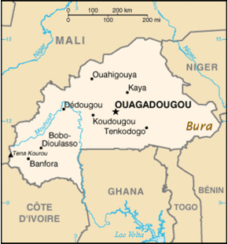The Bura Iron Age culture (3 rd to 11 th century CE ) is named for the Bura archaeological site first discovered in the [Tillabéry Region](http://en.wikipedia.org/wiki/Tillabéry_Region), [Tera Department](http://en.wikipedia.org/wiki/Tera_Department), SW [Niger](http://en.wikipedia.org/wiki/Niger), in 1975. Two other sites of especial note are Asinda and Sikka in Burkina Faso and Niger respectively. The Bura culture encompasses a set of [archeological](http://en.wikipedia.org/wiki/Archeological) sites in the lower [Niger River](http://en.wikipedia.org/wiki/Niger_River) valley bordering SW [Niger](http://en.wikipedia.org/wiki/Niger) and SE [Burkina Faso](http://en.wikipedia.org/wiki/Burkina_Faso). Excavated objects include terracotta heads, vessels and funerary urns, stone heads and iron arrow points. The terracottas have distinctive raised clay curvilinear motifs of unknown meaning.

The Bura culture belongs to a set of archaeological sites in the middle Niger valley in an area 250km long and about 150 km wide.   
The Bura site consists of many individual [necropoleis](http://en.wikipedia.org/wiki/Necropoleis) with coffins crested by unusually-distinctive [terracotta](http://en.wikipedia.org/wiki/Terra_cotta) [statuettes](http://en.wikipedia.org/wiki/Statuette). The main [necropolis](http://en.wikipedia.org/wiki/Necropolis) itself has a diameter of about one kilometer. Burial mounds, religious altars, and ancient dwellings occur here over a large area. In 1983 a site 25 meters by 20 meters was excavated.

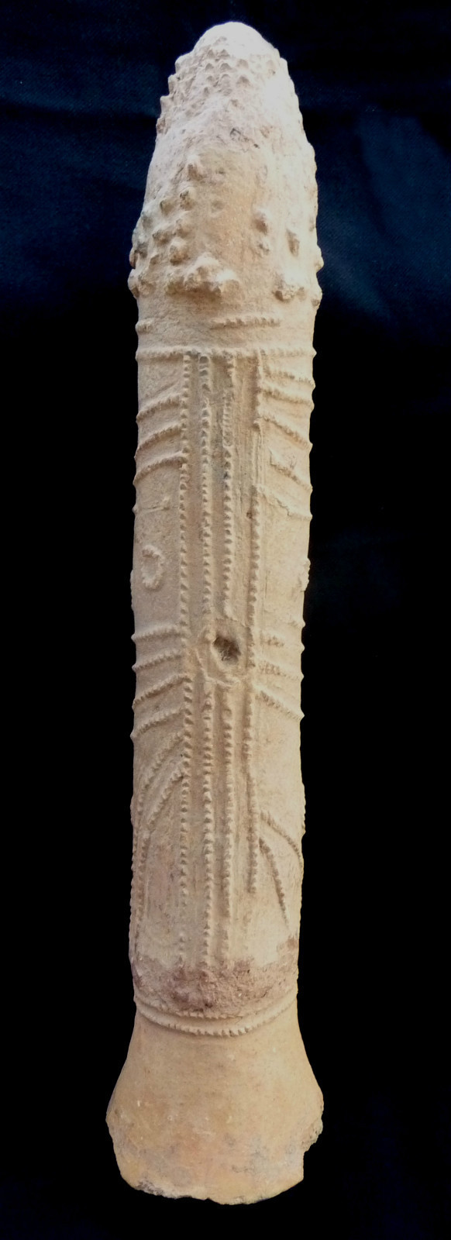

1st century B.C.-1,000 A.D.. Height cm. 47,5 (18.70 In.)

The Bura terracotta pieces originate from what is now Burkina Faso. The name Bura coming from the burial ground where the first archaeological pieces were found. Asinda and Sikka are two more precise locations, inside this larger excavation area.

The first Bura archeological site was discovered in 1975, 150 kilometers north-west of Niamey in the Volta River delta in Niger, in the region controlled by the Songhaï Empire from the 7th to the 16th centuries. Terra cotta pieces such as heads, urns and pottery are found in abundance in this region.

Funeral urns in phallic forms were made to be placed in the tomb of their deceased amongst personal effects such as arrowheads, lances, clothing, teeth and bones. Some are very tall (80 centimeters) and are topped off with small heads. Then, a « baura » was put on the tomb with its opening looking the skies, exactly like our tombstones or burial plaques.

More recently, many Bura ["rat-tail"](http://en.wikipedia.org/wiki/Rat_tail) [iron-age](http://en.wikipedia.org/wiki/Iron_age) [spear-points](http://en.wikipedia.org/wiki/Spear) have also entered the [Euro-American](http://en.wikipedia.org/wiki/Euro-American) collectors market.[[6]](http://en.wikipedia.org/wiki/Bura_archaeological_site" \l "cite_note-5)

Bura site is located in a circus about 1 km in diameter open to the southeast and dominated by outliers of high continental terminal 10 to 20 m.  
  
The site of the necropolis was discovered Bura way chance in 1975 to 150 km northwest of Niamey. Part excavated 25 meters long from north to south and 20 m east to west.  
  
Bura includes three types of sites it is not always easy to distinguish from each other:  
  
    ¨ se burial sites characterized by a particular kind of coffin jars or urns made anthropomorphic pottery statuettes topped heads, laid down on the ground and containing human skeletons in asinda-Sikka. These sites include two distinct archaeological levels.  
    ¨ sites altars and religious ceremonies characterized by accumulations of large blocks of stone form a sort of flattened tumulus or esplanades to asinda as-Sikka at Tondi Karey-to-Jaje Tondi, or Tondi Mebera . There are fragments of foot tripod vases and pottery fragments in the form of small cylinders painted.  
    ¨ settlement sites difficult to identify. But the discovery of fragments of vases and tripods sometimes a few small piles and rows of boulders show a human presence. Also encountered on site waste knapping flint or quartzite representing the site in frame arrows and ceramic thin-Kosendo gorizo ​​located west of cemetery behind a hill.  
  
The general structure of the system of site occupancy of space Bura, seems to revolve around two poles, the necropolis and the religious altar. The necropolis is almost always located in protected areas.  
  
In the necropolis, jars coffins or urns anthropomorphic clay were laid down on the initial soil and were then covered by a wind remobilisation later in the 13th century.  
  
The urns are usually topped with heads of statuettes anthropoid a generally anthropomorphic. And can be distinguished:  
  
    1. Vases or tabular longiformes high 70 to 80 cm and a diameter of 10 to 30 cm is surmounted statuettes complete character is mounted rider. These serve as supports for vases and statuettes are sometimes their bodies.  
    2. Vases hemispherical top 20 to 40 cm and a diameter of 10 to 30 cm usually overcome statuettes head.  
    3. Jars semi-ovoid high of about 50 to 70 cm and a diameter of 40 to 60 cm supports either full or statuettes statuettes heads.  
  
Geological expertise necropolis reveals that based on the latest wind remobilisation erg old prior to the 2nd or 3rd century J. C and has been covered during the relatively arid began after the 13th century. The period of use would therefore be between the 3rd and the 13th century J. C.  
  
Bura contains the oldest equestrian statues in terracotta Niger Basin.

However, it is not yet known how the entire Bura system linked up to other [ancient](http://en.wikipedia.org/wiki/Ancient) [African cultures](http://en.wikipedia.org/wiki/African_culture) and to such later [Islamic](http://en.wikipedia.org/wiki/Islam)-influenced [Sahelian kingdoms](http://en.wikipedia.org/wiki/Sahelian_kingdoms) as [Ghana](http://en.wikipedia.org/wiki/Kingdom_of_Ghana), [early Mali](http://en.wikipedia.org/wiki/Pre-Imperial_Mali), [later Mali](http://en.wikipedia.org/wiki/Mali_Empire), or [Songhai](http://en.wikipedia.org/wiki/Songhai_Empire). [[1]](http://en.wikipedia.org/wiki/Bura_culture" \l "cite_note-whc.unesco.org-0)

* 1. ^ ***[a](http://en.wikipedia.org/wiki/Bura_culture" \l "cite_ref-whc.unesco.org_0-0)*** ***[b](http://en.wikipedia.org/wiki/Bura_culture" \l "cite_ref-whc.unesco.org_0-1)*** ***[c](http://en.wikipedia.org/wiki/Bura_culture" \l "cite_ref-whc.unesco.org_0-2)*** [The Bura Archeological Site, UNESCO World Heritage Centre, translated into English](http://whc.unesco.org/en/tentativelists/5045/)
  2. **[^](http://en.wikipedia.org/wiki/Bura_culture" \l "cite_ref-1)** Duncan E. Miller and N.J. Van Der Merwe, 'Early Metal Working in Sub Saharan Africa' *Journal of African History* 35 (1994) 1-36; Minze Stuiver and N.J. Van Der Merwe, 'Radiocarbon Chronology of the Iron Age in Sub-Saharan Africa' *Current Anthropology* 1968.
  3. **[^](http://en.wikipedia.org/wiki/Bura_culture" \l "cite_ref-2)** Note the exhibits of Bura culture artifacts at the Hamill Gallery at [[1]](http://www.hamillgallery.com/BURA) and the Barakat Gallery at [[2]](http://www.barakatgallery.com/)

http://whc.unesco.org/en/tentativelists/5045/

